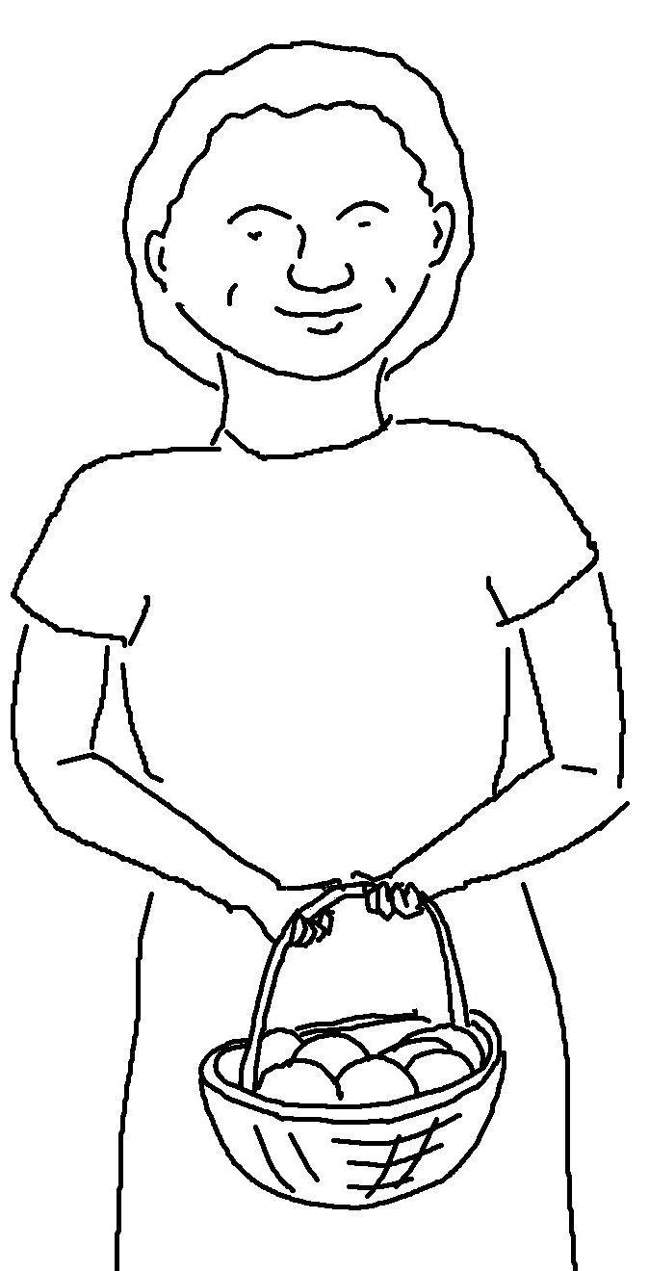
Give, and you will receive.
Matthew 8:27_{NLT}

